Common Garden Aphid Survey Protocol
Katherine Muller, 14 June 2012

Survey area: 20mx20m in C1

Positions: 881-900, with plant positions every 0.5m along the row

Rows: 26-45

Total number of positions surveyed: 780

Materials: meter stick, visor

People: KM, GK, SW, MW, KK, JG, SSL, AK, LK

General considerations:

- There are a lot of items to remember in this survey. It will help to alternate measurer and recorder in each row. The recorder should help the measurer keep track of what information to observe.
- Pay careful attention to the row and position number. It is easy to skip entries. Whenever you reach a flag, verify that you are at the correct location.
- When you’re measuring a plant, try to minimize disturbance of aphid colonies. Avoid rubbing the surface of the leaves and exposing aphid colonies to direct sunlight.
- I included some pictures to help you develop search images. There is a decent collection of pictures on the flog: (http://blog.lib.umn.edu/wage0005/echinacea/imagesForCGMonitoringProtocol.htm#_aphids).
- There are several categories that involve counting leaves. All of these include only basal leaves, not cauline leaves (leaves on a flowering rosette). The reason for this is that when we take common garden measurements, we will only record the number of basal leaves.
- Remember to check the “completed” box when you have finished surveying each position. Entries will not import to the computer unless this box is selected. If you are unsure about an entry and need to return to that position, leave this box unchecked.

Procedure:

Row assignments:
The common garden is arranged in rows (east-west location, or x-axis) and positions (north-south location, or y-axis). We will be conducting the survey from south to north, surveying 19 positions along each row. Everyone will work in pairs, surveying a total of 20 rows in a random order. To assign rows, I will provide a randomized list of rows 26-45 and each pair will sign up for a row in the order of the list. Next to each row, write the initials of the measurer, followed by the recorder. This will help me verify who did what later on.

Recording data:
One person will measure plants while the other records data. You should maintain the same measurer and recorder for each row, then switch when you start a new row. When you are recording data, you should use the visor of the person measuring. This will make it easier to see who was making each observation, since each visor is programmed by name. Be sure to put the initials of both the measurer and recorder in the visor form.

Collecting data—Visor form
Select the form “AphidSurvey2012” and press “new” to create the first entry. When you receive your row assignment, make a new entry on the visor form and enter the row number and the first position number (881). To move on to the next position, press the “end” button. The visor will automatically make a new entry at the next position a half meter away (881.5). After you complete position 900, press “end” to make an empty record, then press “end” again to return to the forms page. Press “Yes” when it asks you if you want to delete this record. You only need to enter the initials of the measurer and recorder for the first record in each row.

Here is an explanation of all the entries in the form. I recommend looking through the form in your visor before you start.

Row and Position
When you begin a row, the first step is to find position 881. There are flags marking every 5 rows and 5 positions, located approximately 10 cm north of the plant position. To find position 881, use the meter stick to measure 1m from the flag at position 880. Try to measure from a plant or a staple, if you can find one.

Status12
The first step at any position is to enter the status of the plant. The options are can’t find, flowering, basal, staple, dead lvs (this year’s), dead lvs (last year’s), wooden stake only, and rebar. A plant is considered flowering if it has any vertical development (stem), even if there is no functional head. Enter “dead lvs (this year’s)” if you see brown, crisp Echinacea leaves, but no living plant. Last year’s dead leaves will be grey in color. If you can’t find anything, try measuring from a different marker (e.g. a plant 0.5 or 1m north, or a plant 1m east). Look from different angles, stand up, and get a second opinion from your recorder. Only enter “can’t find” if you are confident that there is no plant or staple.

Wrinkled Type
Check boxes if there are wrinkled basal or cauline leaves.

Wrinkled Basal Lvs
Record the number of wrinkled basal leaves. If there are only wrinkled cauline leaves, be sure to check the box under “Wrinkled Type.” It can be a little tricky defining a wrinkled leaf, since many Echinacea leaves are twisted or curved. Wrinkled leaves will have a rough, dappled texture and a twisted or wavy shape. If a leaf is twisted or curled, but has a smooth surface, it is not considered wrinkled.

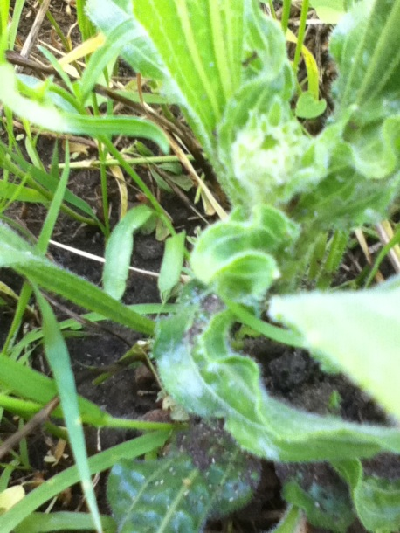

Aphid Occupied
Record the parts of the plant that have aphids on them (leaves, stem, heads). For the head, look on the top of the head, between florets, then look on the underside of each head. Aphids often feed on the bracts beneath the flower head.

Basal Lvs with Aphids
Check both sides of each leaf for aphids, taking care to move leaves by the tip or the edges. Record the number of basal leaves that have aphids on them. You may want to use this as an opportunity to estimate the total aphid abundance (see Ants/Aphids).

Ants/Aphids
There are check boxes for abundance categories of aphids and ants. This is the total abundance of aphids and ants on the plant. For aphids, the categories are 0, 1, 2-10, 11-80, and >80. For ants, the categories are 0, 1, 2-10, and >10. Check both sides of each leaf, being careful to minimize disturbance of aphid colonies. I recommend holding leaves by the tips or edges. Also, be careful not to expose aphid colonies to direct sunlight, since this will cause them to scurry. The abundance is a rough visual estimate. I recommend counting by groups of 5, 10, or 20.
There is also a check box for domatia. These are dirt clumps that are constructed by ants. They can vary in size, but tend to appear as a mound or clump. Domatia can be found on leaf surfaces, stems, or heads.

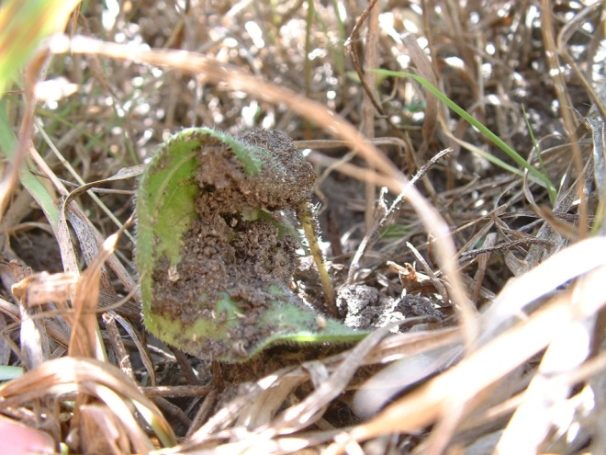

Stages Present:
Check boxes for nymphs, wingless apterae, and winged apterae. Nymphs are small and green, wingless apterae are larger, usually a dark brown or green. Winged apterae may be fat and greenish, or skinny and black, depending on whether they are gravid. Here are some pictures for your search image:
This colony has a mix of nymphs and wingless apterae. These apterae are particularly fat and dark. Often, apterae will have a greenish tint.

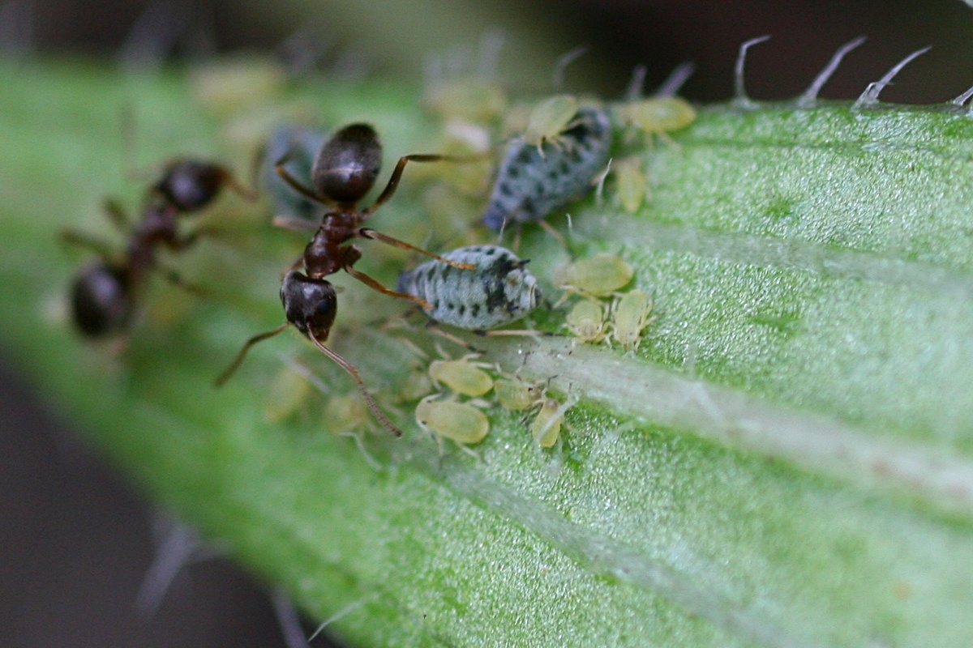

This colony has a couple of winged aptera, signified by the red circle. There’s also an example of what we’re calling “white fuzzy”. I think it’s some sort of mealy bug or scale insect.

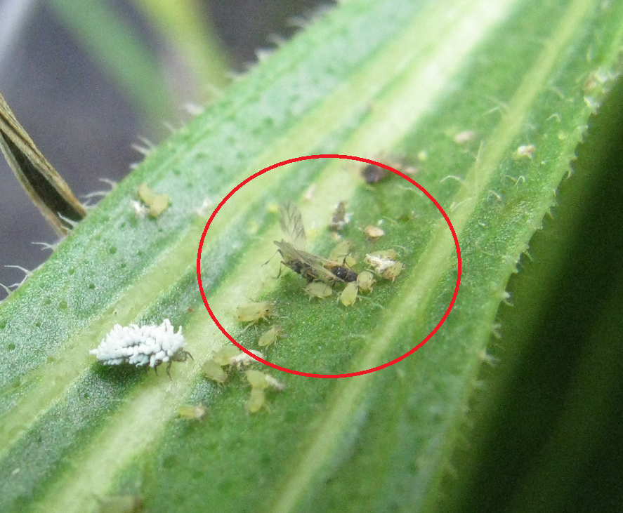

Here is a gravid winged aptera:

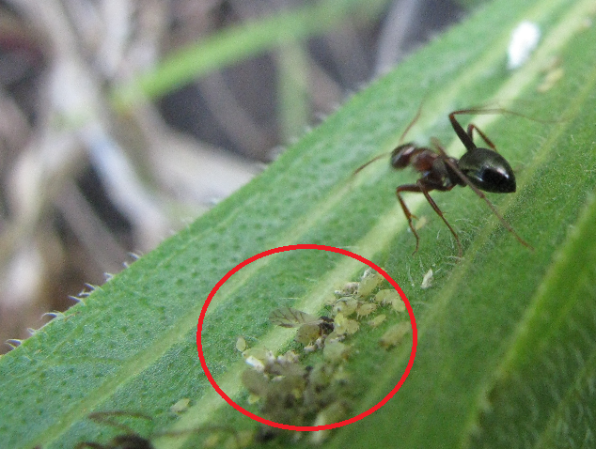

Other insects:
If you notice other insects present on the plant, check a box in this category. For insects not in this list, check the box for “Other” and make a note in the notes section.
-Spittle
-Thorn hopper
- Ladybird beetle (a.k.a. lady bug)
- beetle (this is any other type of beetle)
- Leaf miner
-Egg sac
- White fuzzy
- Spider
- Grasshopper
- Pupa (e.g. a caterpillar)
- rolled lf.
- Other (Note)

Herbivore damage categories:

BLvs Ins Damage
This is the number of basal leaves with either chew marks or holes.

Damage Types
Check the boxes for chew marks or holes. This includes both basal and cauline leaves.

Completed
Check this box when you are finished with the entry and confident that you are at the right location. If this box is left unchecked, the records will not be uploaded to the computer.

Observer Initials
Initials of the person observing the plant. The observer’s visor should be used to record data. Both observer and recorder initials are required on the first entry, but will automatically fill in on subsequent entries.

Recorder Initials
The initials of the person taking data.

Notes:
This is a place to note observations that are not on the form. These may include other insects, oddities in the plant, procedural issues, etc. Be clear and concise in any notes you make.

