Taking Images of Insects Using a Microscope:

Materials:
~ Carl Zeiss CL 1500 ECO Microscope with lighting system
~ Monitor, Keyboard, and Computer
~ Canon PowerShot G10 14.7 Megapixel Camera
~ AxioVision 4 Computer Program
~ Canon Remote Capture DC Computer Program
~ Camera USB Cord
~ Specimens

Procedure:
- Plug USB cable into the camera that is set into the Carl Zeiss CL 1500 ECO Microscope with lighting system set up. Plug the USB cord into computer and turn on the camera before starting the computer up so the computer registers that the camera is attached.
- Open AxioVision 4 by Opening My Computer> C:> Program Files> Carl Zeiss Vision> AxioVision4.
- Open Remote Capture CD by Opening My Computer> C:> Program Files> Canon> CameraWindow> RemoteCapture> RemoteCaptureDC.exe.
- Make sure the white dots on the eyepieces match with the zero on both lenses before taking any pictures.
- Adjust specimen onto stage center. Adjust lighting by using the control knob on the lighting unit (usually 1.5 is the clearest), the arms with the lights that shine onto the stage, and the stage center can be flipped to white or black for reflective purposes.
- Focus the specimen into view by using the course and fine adjustment knobs on the microscope while peering through the eyepieces onto the specimen.
- When the specimen is in focus, switch the lever on the back of the microscope’s neck so the camera is in focus of the specimen. You should now only be able to see through the left eyepiece.
- Maximize the Remote Capture CD Program on your computer. Focus the displayed image to Digital 2.2 by using the adjustment bar on the right of the image (The one with the trees on it). If the lighting and the image look clear, then click the Release button above the adjustment bar (displayed below). 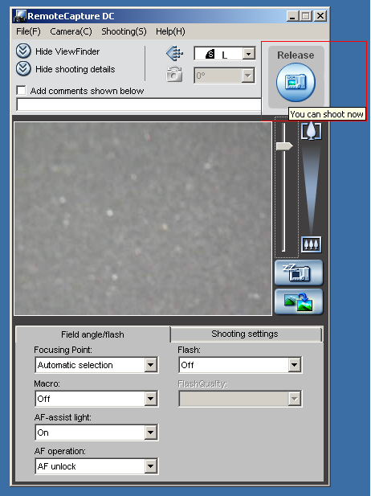
- Maximize the AxioVision Program window and click Open Image. This should automatically take you to My Documents. Click My Pictures and open the desired image. Check the image for quality. If the picture looks unclear, adjust the lighting accordingly and retake the picture.
- Save file.
- Put all specimens away and turn off lighting system. Turn off camera and disconnect USB cord from both the camera and the computer. Place blue protection cover over microscope and shut down the computer. Cleaning the stage center with a Kimwipe is also a good idea before covering the microscope.



