Amy Dykstra’s Crossing Experiment – 2021
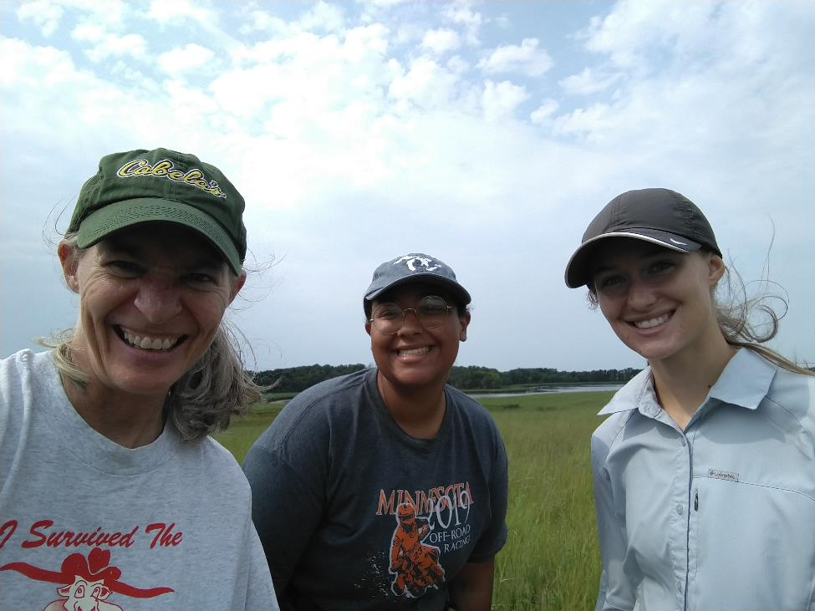
My field assistants and I found 33 basal plants and 2 flowering plants (1 with vertical development only, and 1 with one head). These were the first plants to flower in this experiment! The plant with one head (Figure 1) grew from an achene produced by a between-population cross between a Steven’s Approach maternal plant and a NWLF pollen donor. The plant with vertical development grew from an achene produced by a within-population cross between an AA maternal plant and an AA pollen donor.
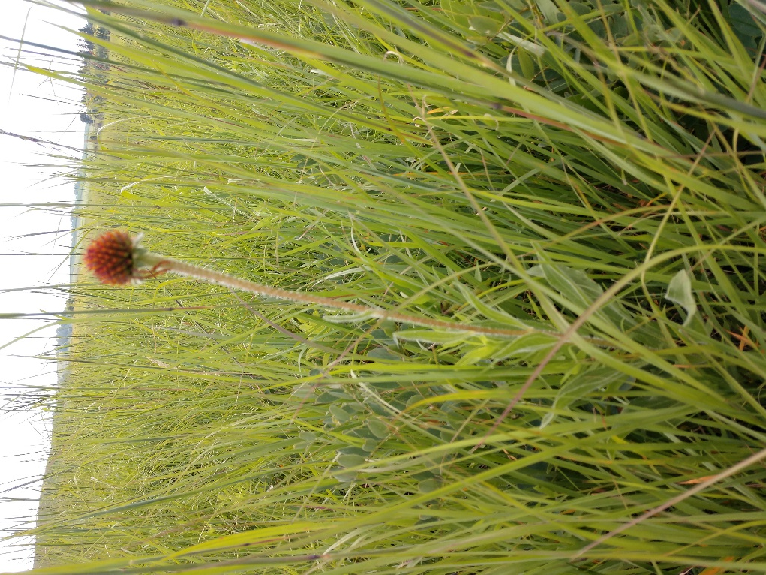
Figure 1. First flowering plant in Amy Dykstra’s crossing experiment
Here’s a graph of the survival and flowering over the course of the experiment. The achenes were sowed in fall 2008, and the first seedlings emerged in 2009.

