Cross pollination and the potential for hybridization between native and non-native Echinacea
Shona Sanford-Long
Middlebury College
January 30, 2013

Abstract
Echinacea angustifolia, commonly narrow-leaved purple coneflower, is a long-lived, herbaceous perennial native to Minnesota prairies. In some prairie restoration projects Echinacea pallida, a non-native species, has been introduced in its place. While a previous study demonstrated that hybridization between E. angustifolia and E. pallida is possible, the likelihood of inter-specific crosses remains unknown. In this study I performed reciprocal crosses within a population of each species and between the two, to investigate which crosses were more likely to demonstrate compatibility and lead to seed set. Self-incompatibility is a mechanism by which some plants can react only to pollen grains with S-locus alleles that differ sufficiently from those of the style receiving pollen. When styles react by shriveling they are considered compatible. I used a population of seven flowering E. pallida from a restored plot, and seven flowering E. angustifolia from a larger native population 150-200 meters away. Compatibility and seed set rates differed between all cross types and compatibility did not predict seed set equally across cross types. Pollen was most likely to be accepted by E. angustifolia, and each species was more likely to accept interspecific pollen than pollen from the same species. Seed set was lowest (45% of shriveled styles led to seed set) in intraspecific E. angustifolia crosses and highest (84%) in intraspecific E. pallida crosses. These results indicate that the introduction of E. pallida is likely to have a negative impact upon native populations of E. angustifolia in Minnesota prairie remnants.

Introduction
The introduction of foreign species into native habitats is increasingly becoming cause for concern. With the introduction of a non-native plant genetically related to an indigenous species, invasion through hybridization can amplify the potential for population degradation (Rhymer and Simberloff 1996, Vilà et al. 2000). While it is possible for hybrids to have higher, equivalent, or lower fitness relative to that of their parents (Campbell et al. 2008; Miglia et al. 2005) any of these outcomes could be equally effective at changing the native population.
The tallgrass prairie of the Great Plains of North America once spanned 162 million hectares, reaching from Canada to Texas. Since European settlement, the extent of tallgrass prairie has decreased by roughly 95% (Sampson and Knopf 1994). Today, the prairie remaining in the state of Minnesota is mostly relegated to roadside ditches and hills too steep for development. Echinacea angustifolia, commonly known as narrow-leaved purple coneflower, is a long-lived perennial, and the only Echinacea species native to Minnesota prairies. E. angustifolia is one of many species that has suffered from habitat loss due to prairie fragmentation (Stuart Wagenius 2006).
The Hegg Lake Wildlife Management Area (HLWMA) in western Minnesota contains remnants of native prairie, and in recent years these native patches have been linked by restoration projects on adjacent land. Although restoration managers intended to plant native species in these restoration plots, Echinacea pallida has germinated and is now flowering. Although E. pallida’s native range reaches as far north as Wisconsin, Iowa, and Ontario, and overlaps in some places with that of E. angustifolia, it is not native to Minnesota (USDA 2013). This substitution of a non-native Echinacea species in place of E. angustifolia is not uncommon in prairie restorations, and happens for a variety of reasons. Some restorers do not know that only E. angustifolia is native, and seed for E. pallida may be cheaper and easier to find than seed for E. angustifolia (Stuart Wagenius, personal communication.
In 2010 and 2011 respectively, Kiefer and Goldsmith (unpublished) found that cross-pollination and hybridization between these two species of Echinacea was possible, but little is known about the rates at which plants of each species are likely to accept pollen from the other, or from different plants of their own species, or the likelihood that a given cross where pollen was accepted will lead to a viable seed.
Echinacea angustifolia, (Asteraceae) is self –incompatible by a sporophytic system, wherein S-locus alleles in the stigma and pollen coat must differ for a mate to be accepted as compatible (Wagenius et al 2007). In this system, transfer of genetically different pollen onto the style leads to style shriveling (signifying compatibility) within about 24 h, while incompatible pollen has no effect (Wagenius 2004). Compatibility as indicated by style shriveling gives an early indication of the potential for seed set and pollen interference.
The goal of this study is to compare compatibility and seed set rates between interspecific and intraspecific crosses of E. angustifolia and E. pallida, to gain a better comprehension of the ramifications of introducing E. pallida into Minnesota prairies. Understanding differential compatibility rates and seed set among these three cross-types will provide insight into the potential for decreased seed set and hybridization with the introduction of E. pallida into habitats containing native E. angustifolia. In order to understand these interactions I test three hypotheses. Hypothesis one: compatibility rates will differ between cross types. I expect that these differing compatibility rates due to differences in genetic diversity of the two species. Hypothesis two: compatibility rates will be indicative of seed set. Hypothesis three: cross types with higher rates of compatibility will also have higher seed set.

Methods
Study Site
The population of E. pallida was located in the Hegg Lake Wildlife Management Area (HLWMA) near Kensington, Minnesota, where E. pallida was planted in a restoration project about seven years ago. We found seven flowering E. pallida at this site on June 18, 2012 by walking the site in a row and searching visually. I chose E. angustifolia from a native population on a hill 150-200 meters away from the restoration plot, also within the HLWMA. This site was chosen because it contains a native population in close proximity to the introduced E. pallida, and the interactions shown in this study will be directly applicable to the future of this site. Seven plants were chosen from this population that would flower at the same time as the population of E. pallida.

Compatibility

Using the style persistence measurement method (Wagenius 2004), I performed intraspecific and interspecific crosses on each head. Each flowering head received pollen from as many of the other plants as possible, with the first crosses following the crossing design in figure 1. When there were extra florets that I did not need for other crosses I applied pollen from the maternal plant as a control for self-incompatibility. Because not all of the heads flowered synchronously I added heads into the pattern as they started and removed them when they were done. Some plants had multiple heads or larger heads that allowed for more crosses and I was able to cross these plants with all possible donors. Other plants that had smaller heads or were less synchronous I was not able to cross with all of the desired pollen donors.
On the first day of the experiment I covered all heads with anthers present with pollinator exclusion bags to prevent cross contamination of pollen. On the second day, I collected pollen from all bagged heads by milking pollen from the anthers into a microfuge tube with a toothpick (pollen was generally present by 9:00 am, although on overcast days it emerged later). Pollen was collected every other day and stored in closed microfuge tubes at ~4ºC. I also painted the outer two sides of each bract that subtended a floret where an anther was present, using colors to differentiate between crosses. On the third day, I performed crosses by applying a few grains of the desired pollen to the specified style with a toothpick. After that, I repeated the second and third days, also observing whether styles had shriveled on the second day, until all but two heads had finished flowering. For each cross I pollinated at least five styles, and if at least two thirds of the styles did not show the same response (shriveled or unshriveled) after the first cross, further crosses were performed.
For the majority of crosses, pollen collected the previous day was used. When there was no pollen available from the previous day the, the most recent pollen was used and the date was recorded. Crosses were performed from June 24, 2012 to July 6, 2012. A few styles were damaged by caterpillars towards the end of the season, making it impossible to continue crossing them or collecting their pollen.

Seed Set

Flower heads were harvested when the head was browned and crisp. On August 5th I harvested the heads of all maternal E. angustifolia plants, labeled them with tape on the stem and stored them in an egg carton. On August 11th I harvested the head of plant PAL1003, and on August 15th I harvested the heads of plants PAL1002 and PAL1013. All other E. pallida plants were harvested on August 29th.

All heads were dissected by hand, where achenes (Echinacea fruits containing a single seed) were placed on sticky notes and assigned unique identification numbers from 1-1142. Roughly 50-100 achenes were removed from each head, which was about one third of the total achenes per head. Achenes were identified based on the color of the paint on bracts subtending achenes and the order in which the painted bracts were arranged on the head. The order of crosses and paint colors had been recorded in the field along with pollen donor identification. All achenes were x-rayed for 2 seconds at 18kv (Figure 2), and the presence of an embryo was designated as full, empty, or questionable. All full and questionable achenes were then weighed for confirmation of the designation. Achenes with a weight ≥0.015g were considered full.

Data Analysis

R was used to organize data and perform statistical tests. To categorize compatibility I called crosses that had greater than or equal to six styles crossed and a proportion of shriveled styles greater than 0.6, as well as crosses that had five out of five styles shriveled, compatible. I called crosses that had greater than or equal to 6 styles crossed and a proportion of shriveled styles less than 0.4, as well as crosses that had 0 out of five styles shriveled, incompatible. All other crosses I labeled “unsure” and removed from the analysis. These divisions were selected based on the frequency of crosses by proportion compatibility (Figure. 3). Fisher’s Exact Test was used to analyze differences in compatibility among cross types. At this time, no statistical tests have been performed on seed set data due to time constraints and the complicated analysis necessary.

Results
Style Persistence
Styles had the highest probability (0.97) of shriveling in the maternal E. angustifolia, paternal E. pallida crosses, and the lowest probability (0.68, 30% lower than the highest probability) of shriveling in intraspecific E. pallida crosses (Fisher’s Exact Test, p < 0.01595, alt hypothesis: two-sided. Table 1).

Seed Set
Mean proportion seed set was lowest in E. angustifolia x E. angustifolia crosses [0.45 ± 0.08 (1 s. e., n=18)], intermediate for both interspecific crosses, and highest in within species E. pallida crosses [0.84 ± 0.07(1 s.e., n=15), 87% higher than in E. angustifolia x E. angustifolia crosses].
To characterize the potential for misrepresentative seed set data due to pollen contamination, the proportion of seed set was calculated for only those crosses that were 100% incompatible. One of these incompatible crosses produced seeds in all nine crossed achenes, however the remaining 13 crosses demonstrated zero seed set, indicating that contamination of crosses was likely to be infrequent.

Discussion
As suggested by Kiefer and Goldsmith (unpublished data), this study demonstrates a potential for hybridization between native E. angustifolia and the introduced species E. pallida. With these two species in close proximity to each other, compatibility rates and proportion seed set provide important insights into their prospective interactions.
The results of this experiment show that both species are more likely to accept pollen from interspecific mates than they are from mates of their own species. Furthermore, overall, E. angustifolia styles are more likely to accept pollen than E. pallida styles. Compatibility rates offer an initial measure of the degree of impact E. pallida could have on E. angustifolia. Incompatibility in crosses between the two species would indicate that E. pallida presented no threat to the native by means other than competition. Equal compatibility rates across all cross types would suggest that, assuming pollen transfer rates were equivalent, any cross would have an equal chance of occurring. However, I found neither of these circumstances to be true. The differing compatibility between cross types that I found in this study indicates that certain crosses are more likely to occur than others.
Two possible explanations for these results are due to genetic diversity and ploidy. The origins of the E. pallida population and its degree of relatedness are unknown. Although we know that the E. angustifolia population is native to this location it is also difficult to know how closely those plants are related. The small size of this E. angustifolia population and its distance from other populations suggests that those plants and their progenitors would have had few potential mates and thus may be closely related, yet the high compatibility rates within this population suggest otherwise. Even with these uncertainties, it seems likely that S-alleles would be more diverse between species than within species.
E. angustifolia is widely considered to be a diploid species, however, there has been some debate over the ploidy of E. pallida. It has been suggested that E. pallida is diploid in its southern range and tetraploid in its northern range (McGregor 1968). With these uncertainties and our uncertainty regarding the source of the E. pallida at HLWMA it is possible that the pallida in this experiment were diploid or tetraploid. If they are tetraploid, it is possible that higher selectivity in pollen acceptance by E. pallida could be due to the presence of more different S-alleles in each plant.
Regardless of the causes, this investigation demonstrates that with equivalent transfer of pollen from each species, pollen acceptance is most likely to occur in interspecific crosses. However, pollen acceptance rates did not accurately predict seed set as I had expected they would. For example, compatibility was relatively low in intraspecific E. pallida crosses, yet those crosses that were compatible showed the highest proportion seed set. In intraspecific E. angustifolia crosses on the other hand, compatibility rates were high but seed set was quite low. This indicates potential for a reduction in overall seed set due to false compatibility, which is higher in some cross types than others. Compatibility linked with style shriveling usually means that if pollen that lands on a style is not compatible the style will remain open and receptive to other pollen grains that are compatible. Falsely compatible crosses cause styles to shrivel and prevent them from accepting any other pollen without leading to seed set. The self-incompatibility system of Echinacea acts as a prevention against selfing and the associated, substantial negative fitness consequences of biparental inbreeding depression by only allowing crosses with sufficient genetic diversity (Wagenius et al. 2010), however it appears that it may sometimes allow crosses between parents that are too diverse to lead to seed set after shriveling.
High rates of falsely compatible crosses lead to low seed set and pollen interference. In the context of mixed species populations, false compatibility could be beneficial or harmful to maintaining species purity. High false compatibility in intra-specific crosses would lead to low reproductive rates, but would limit the styles available to receive potentially compatible pollen from other species further than if only truly compatible crosses led to style shriveling. In this experiment, where the highest compatibility rates for each species were found for interspecific crosses, false compatibility could help prevent hybridization. Seen in a slightly different perspective however, if falsely compatible crosses of a specific cross type also prevent truly compatible pollen of the same paternal species from landing on receptive styles, false compatibility would lead to decreased populations of that cross type. This may indicate an important trade off between high compatibility rates and high seed set.
Repercussions of hybridization on arthropods
Hybridization and pollen interference leading to decreased native populations is not just an issue for the sake of keeping populations pure and native. It will also have an impact upon arthropod populations. In an investigation of aphids at the HLWMA and other sites in western Minnesota, Hobbs and Lyons (unpublished) found that the specialist aphid Aphis echinaceae, which is present on E. angustifolia, does not survive when transferred to E. pallida. Personal observations and preliminary quantification of characteristics of E. pallida and E. angustifolia suggest that morphological differences between the two species may influence herbivory and survival of arthropods. Characteristics of pallida x angustifolia hybrids have not yet been quantified. While it is possible that native arthropod species could survive on hybrids, and adapt to E. pallida through the Hybrid Bridge Hypothesis as proposed by Floate and Whitham (1993), arthropod community composition remains likely to shift to some degree. With arthropods as key players in natural systems, the changes in arthropod community composition could have broader impacts on other taxa as well.
Future Work
The results presented in this paper are limited to compatibility rates and seed set of crosses between the two described populations. Further information will be gained in a future study on germination and growth rates of all full achenes from this study. Additionally, I have begun to quantify characteristics of the parental plants that will then be compared to characteristics of hybrid offspring. These characteristics include capitulum height, ray floret color and shape, bract color, pubescence, and leaf size and shape. I have also reorganized the data from earlier studies on crosses with maternal E. angustifolia and paternal E. pallida by Kiefer and Goldsmith (unpublished) so that these three data sets are comparable. This will allow us to understand more about how the populations at HLWMA fit into the larger picture of interactions between E. angustifolia and E. pallida.
To expand this study further it would be helpful to study the potential for hybridization between E. angustifolia and E. purpurea (another non-native Echinacea species frequently planted in prairie restorations). It would also be useful to study rates of pollen transfer at HLWMA to understand the likelihood of crossing without hand pollination, and to look further into the tradeoffs between false compatibility and low true compatibility.

Acknowledgements
I would like to thank Stuart Wagenius, Ruth Shaw, and Gretel Kiefer for their support and guidance on this project. I would also like to thank the other Echinacea Project interns for help gathering data and input. I would like to thank the NSF REU program, the Echinacea Project, and Middlebury College for funding my work. This work was supported by NSF awards 1052165 and 1051791, including REU supplements.

Literature Cited

Campbell, D. R., N. M. Waser, G. Aldridge, and C. A. Wu. 2008. Lifetime fitness in two generations of Ipomopsis hybrids. Evolution. 62(10): 2616-2627.

Floate, K. D. and T. G. Whitham. 1993. The "Hybrid Bridge" Hypothesis: Host Shifting via Plant Hybrid Swarms. The American Naturalist. 141(4): 651-662.

McGregor R. 1968. The taxonomy of the genus Echinacea (Compositae).
University of Cansas, Science Bulletin 48: 113–142.

Miglia, K. J., E. D. Mcarthur, W. S. Moore, H. Wang, J. H. Graham and D. C. Freeman. 2005. Nine-year reciprocal transplant experiment in the gardens of the basin and mountain big sagebrush (Artemisia tridentata: Asteraceae) hybrid zone of Salt Creek Canyon: the importance of multiple-year tracking of f itness. Biological Journal of the Linnean Society. 86: 213–225.

Rhymer, J. M. and D. Simberloff. 1996. Extinction by Hybridization and Introgression. Annual Review of Ecology and Systematics. 27 :83-109.

Samson, F. B., and F. L. Knopf. 1994. Prairie conservation in North America. Bioscience 44: 418–421.

USDA. Natural Resources Conservation Service, PLANTS profile for Echinacea pallida. Accessed on January 30, 2013. http://plants.usda.gov/java/profile?symbol=ECPA&mapType=nativity&photoID=ecpa_002_avp.tif

Vilà, M., E. Weber, and C. M. D’Antonio. 2000. Conservation implications of invasion by plant hybridization. Biological Invasions 2: 207–217, 2000.

Wagenius, S. 2004. Style persistence, pollen limitation, and seed set in the common prairie plant Echinacea angustifolia (Asteraceae). International Journal of Plant Science. 165(4): 595-603.

Wagenius, S. 2006. Scale dependence of reproductive failure in fragmented Echinacea populations. Ecology 87: 931-941.

- Wagenius, S., E. Lonsdorf, C. Neuhauser. 2007. Patch aging and the s-Allee effect: breeding system effects on the demographic response of plants to habitat fragmentation. The American Naturalist. 163(3): 383-397.

Wagenius, S., H. H. Hangelbroek, C. E. Ridley, and R. G. Shaw. 2012. Biparental inbreeding and interremnatn mating in a perennial prairie plant: fitness consequences for progeny in their first eight years. Evolution. 64: 761-771.

Figures and Legends
 |  | E. pallida paternal (where each ID starts with PAL) |  |  |  |  |  | E. angustifolia paternal
 |  | 1002 | 1003 | 1005 | 1004 | 1013 | 1014 | 17167 | 17168 | 17169 | 17164 | 17165 | 17170
E. pallida  Maternal  (where each ID starts with PAL) | 1002 | Gry |  |  | Aqu | Pnk | Wht |  |  |  | Grn | Ind | Vlt
E. pallida  Maternal  (where each ID starts with PAL) | 1003 |  | Gry |  | Aqu | Pnk | Wht |  |  |  | Grn | Ind | Vlt
E. pallida  Maternal  (where each ID starts with PAL) | 1005 |  |  | Gry | Aqu | Pnk | Wht |  |  |  | Grn | Ind | Vlt
E. pallida  Maternal  (where each ID starts with PAL) | 1004 | Aqu | Pnk | Wht | Gry |  |  | Grn | Ind | Vlt
E. pallida  Maternal  (where each ID starts with PAL) | 1013 | Aqu | Pnk | Wht |  | Gry |  | Grn | Ind | Vlt
E. pallida  Maternal  (where each ID starts with PAL) | 1014 | Aqu | Pnk | Wht |  |  | Gry | Grn | Ind | Vlt
E. angustifolia  maternal | 17167 |  |  |  | Aqu | Pnk | Wht | Gry |  |  | Grn | Ind | Vlt
E. angustifolia  maternal | 17168 |  |  |  | Aqu | Pnk | Wht |  | Gry |  | Grn | Ind | Vlt
E. angustifolia  maternal | 17169 |  |  |  | Aqu | Pnk | Wht |  |  | Gry | Grn | Ind | Vlt
E. angustifolia  maternal | 17164 | Aqu | Pnk | Wht |  |  |  | Grn | Ind | Vlt | Gry
E. angustifolia  maternal | 17165 | Aqu | Pnk | Wht |  |  |  | Grn | Ind | Vlt |  | Gry
E. angustifolia  maternal | 17170 | Aqu | Pnk | Wht |  |  |  | Grn | Ind | Vlt |  |  | Gry

Figure 1. Crossing Pattern. The initial crossing plan. Shaded spaces are the crosses that were made first. Different colors differentiate between the three cross types, where there are crosses with each species as maternal and paternal parents. The color that bracts were to be painted was indicated with abbreviations in each cell. Yellow cells are crosses that were to be made if there are extra styles open, and pollen for these crosses was from the same plant that was being pollinated. If there were still available styles after all of these crosses were made satisfactorily, additional crosses were added as necessary.

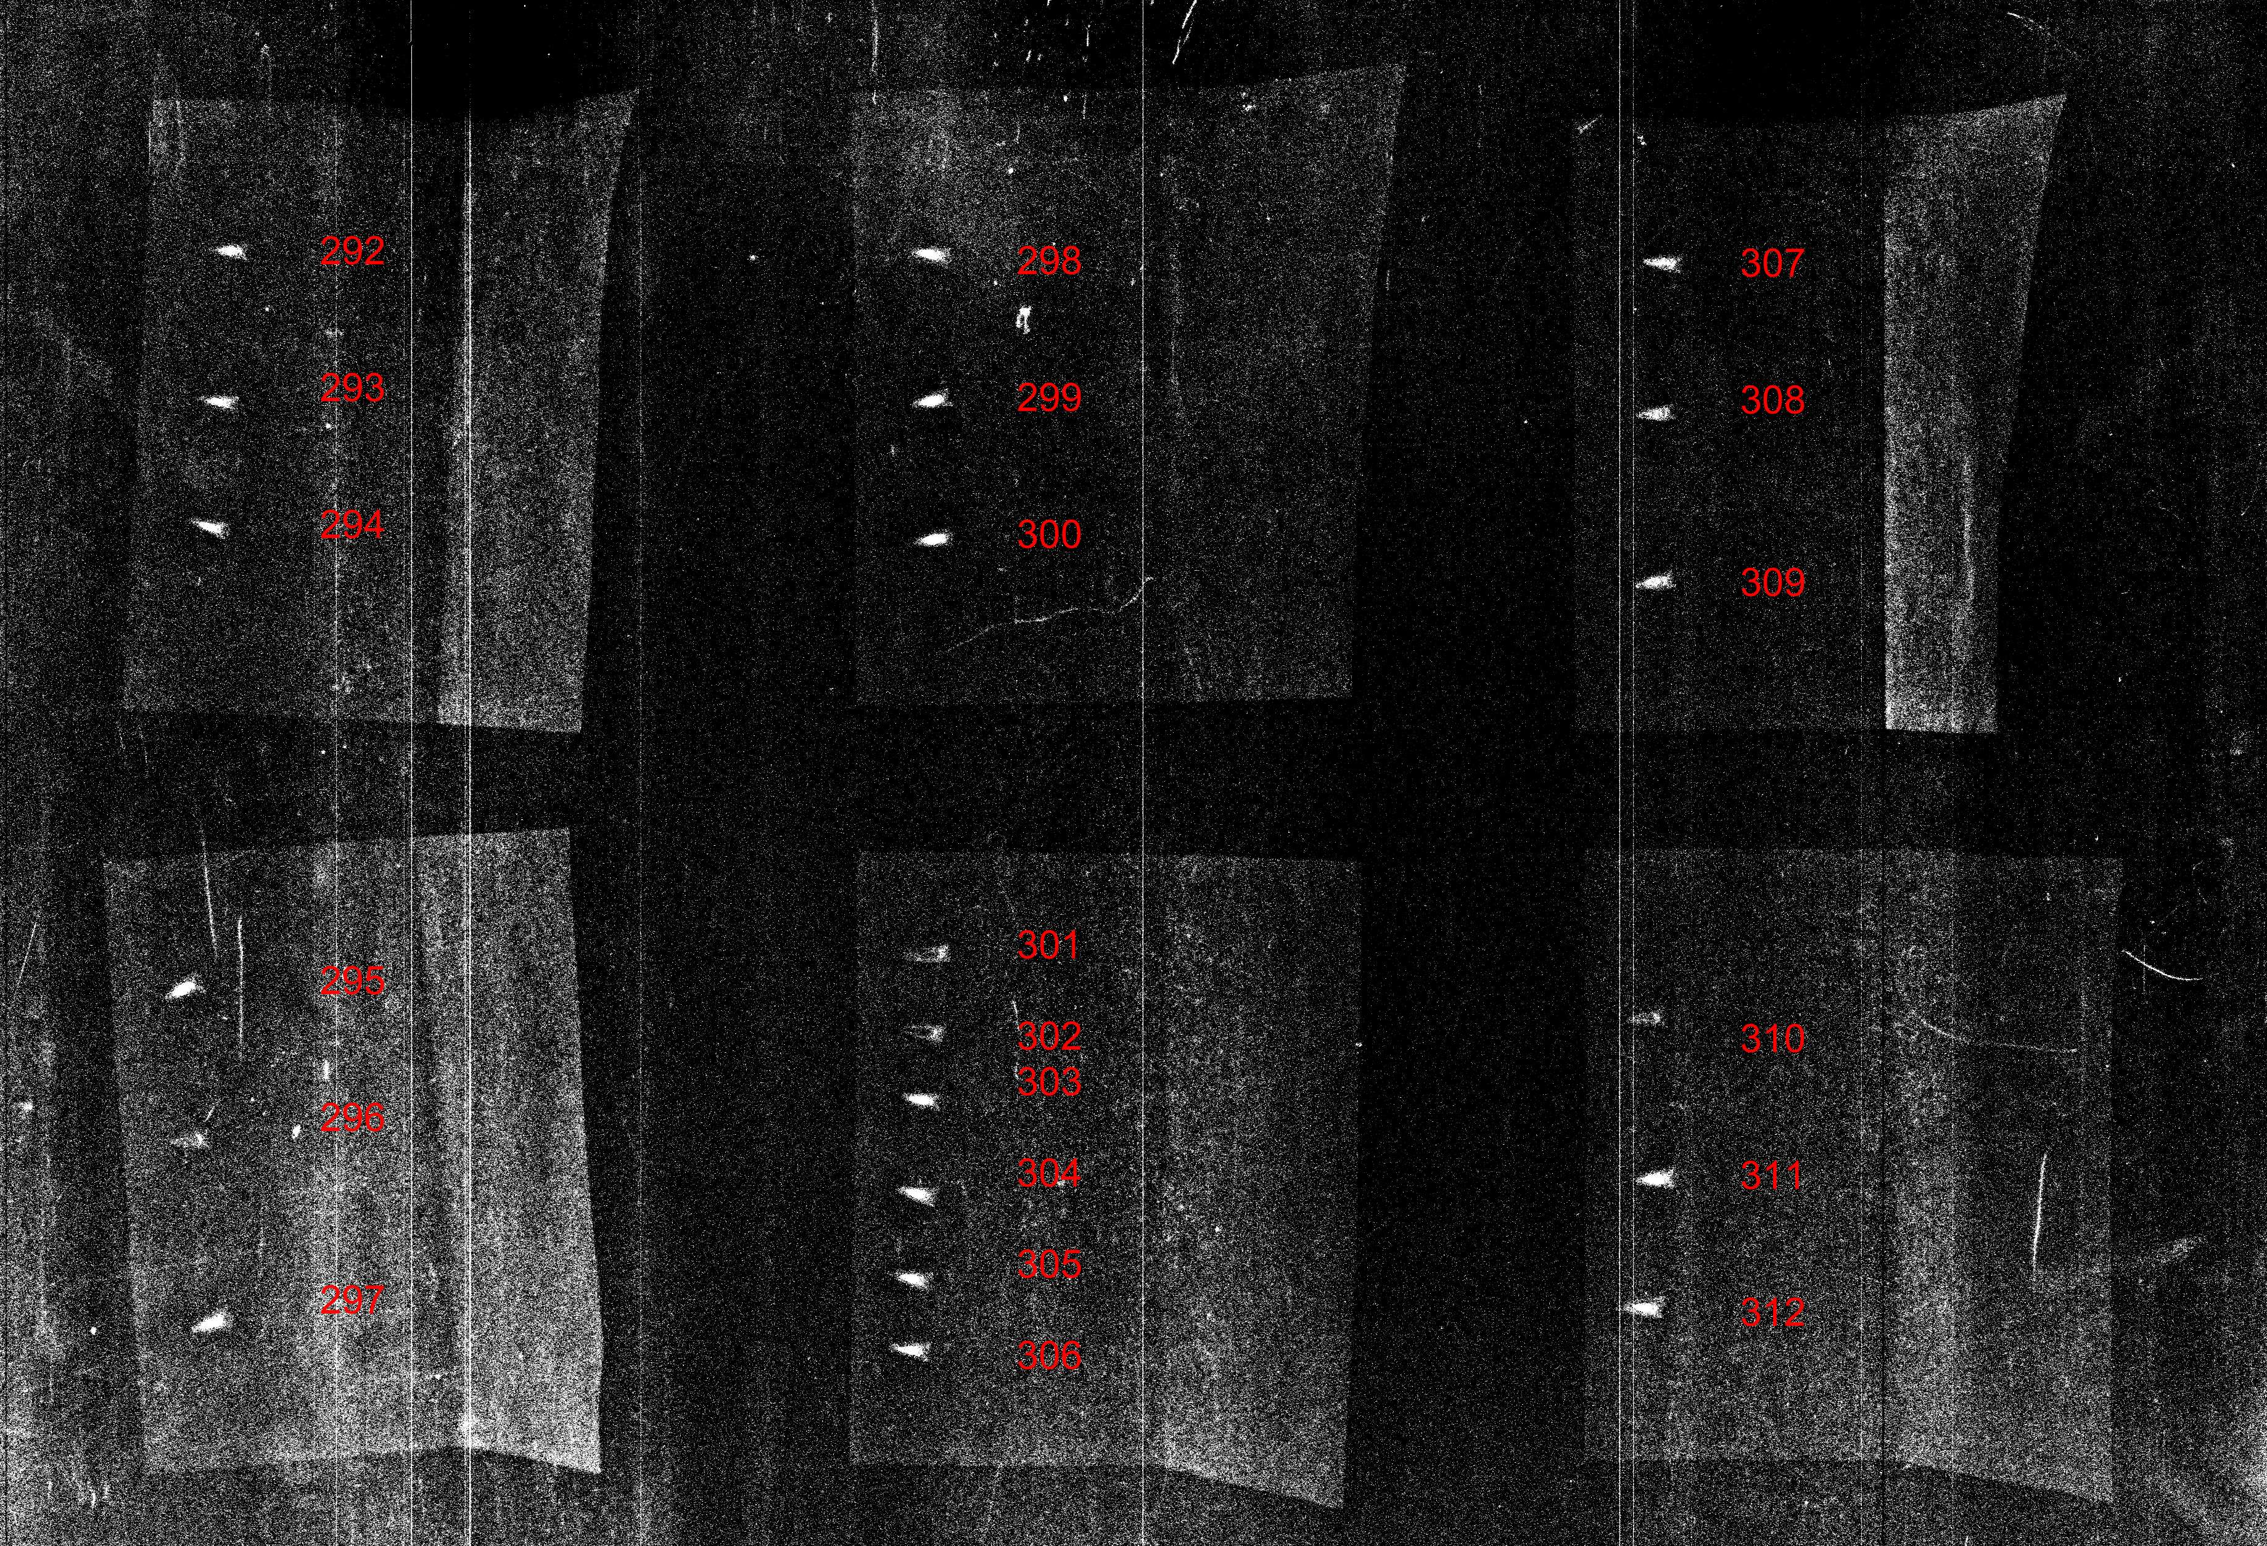
Figure 2. X-rayed achenes. X-rays were used to determine if achenes were full or empty. Full achenes appear bright white (eg. achenes 292-294), while empty achenes have a dark space where the embryo would be (achenes 301 and 302). Where fullness was not easily quantifiable by x-ray, as for achenes 296 and 310, mass was used to determine seed set.
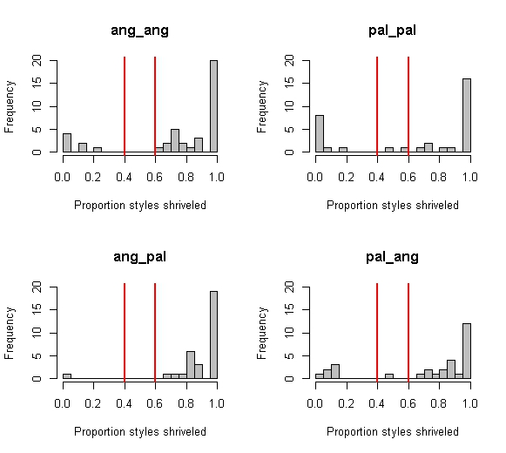

Figure 3. Frequency of compatibility rates by cross type. Histograms of the frequency of proportion styles shriveled (typically out of five or six florets corssed). We assigned compatibility to a given cross based on the proportion of full achenes per cross: Proportions between the red lines were considered “unsure”, to the right of the red lines we assigned “compatible” cross, and to the left of the red lines we assigned “incompatible” cross.

Table 1. Proportion of compatible crosses per cross type. The proportion of crosses that were compatible for each cross type is shown.

Maternal species | Paternal species | Proportion compatibility | Sample size
angustifolia | angustifolia | 0.89 | 34
angustifolia | pallida | 0.97 | 28
pallida | angustifolia | 0.78 | 21
pallida | pallida | 0.68 | 20

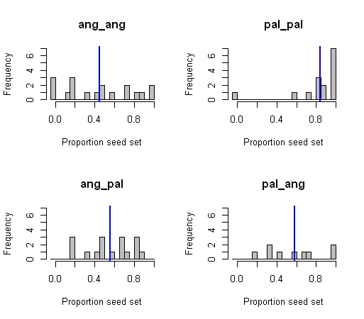
Figure 4. Proportion seed set by cross type. Proportion seed set was calculated for all crosses with 100% compatibility. The frequencies of each proportion are shown by cross type. “ang_ang” indicates crosses with maternal and paternal angustifolia, “pal_pal” crosses with maternal and paternal pallida, “
“ang_pal” crosses with maternal angustifolia and paternal pallida, and “pal_ang” crosses with maternal pallida and paternal angustifolia. Blue lines indicate mean proportion seed set for each cross type. Ang_ang mean = 0.45 ± 0.08 (1 s. e., n=18), pal_pal mean = 0.84 ± 0.07(1 s.e., n=15), ang_pal mean = 0.55 ± 0.06 (1 s. e., n=17), pal_ang mean = 0.58 ± 0.10 (1 s. e.., n=9).

